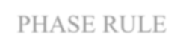

PHASE RULE

INTRODUCTION

All chemical reactions are broadly classified into 2 types:

* + 1. Irreversible Reactions : Zn + H 2SO 4 −−−−−> ZnSO4 + H 2
    2. Reversible reactions:
       1. Homogeneous reversible reactions Eg: N 2(g ) + 3H 2(g)  2NH 3(g)
       2. Heterogeneous reversible reactions

Eg: CaCO 3(s) CaO(s) + CO 2(g)

The reversible reactions arerepresented by 2 arrowsin the opposite directions. The homogeneous reversible reactions can bestudied by the law of mass action and the heterogeneous reversible reactions using thephase rule, given by Willard Gibbs (1874) which is defined as,

PHASE RULE:

If the equilibrium between any numbers of phases is not influenced by gravitational/elecatrl/icmagnetic forces but is influenced by pressure, temperature and concentration, then the number of degrees of freedom

1. is related to the number of components (C) and the number of phases (P) as: F = C − P + 2 EXPLANATION OF TERMS WITH EXAMPLES
   1. PHASE (P):

PHASE is defined as, “any homogeneous physically distinct and mechanically separable portions of a system which is separated from other parts of the system by definite boundaries”.

a) Gaseous phase (g):

All gases are completely miscible and have no boundaries between them. Hence all gases constitute a single phase.

Eg: Air, a mixture of O 2, H 2, N 2, CO 2 and water vapor, etc., constitutes a single phase.

1. Liquid Phase (l):

The number of liquid phases depends on the number of liquids preseanntd their miscibility’s.

1. If two liquids are immiscible, they will form two separate liquid phases. (e.g.) Benzene – Water system.
2. If two liquids are completelymiscible, they will form only one liquid phase. (e.g.) Alcohol *-* Water system.
3. Solid Phase (s):

Every solid constitutes a separate single phase.

(e.g.) Decomposition of CaCO3

CaCO 3(s)  CaO (s) + CO 2(g)

It involves 3 phases namely solid CaCO3, solid CaO and gaseous CO2.

OTHER EXAMPLES:

1. A water system has 3 phases namely one solid, one liquid and one gaseous phase. Ice(s) Water(l) Vapour(g)
2. A solution of a substance in a solvent constitutes only one phase(.e.g.) Sugar solution in water.
3. An emulsion of oil in water forms two phases
4. MgCO 3 (s)  MgO (s) + CO 2 (g)

It involves 3 phases, solid MgCO 3, solid MgO and gaseous CO2.

1. Rhombic sulphur (s) −−−−> Monoclinic sulphur (s). It forms 2 phases.
2. Consider the following heterogeneous system.

CuSO 4(s) + 5H 2O (l)  CuSO 4 . 5H 2O (s)

It involves 3 phases namely,2 solids and 1 liquid phase. 2. COMPONENT (C):

Component is defined as, “the minimum number of independent variable constituents, by means of which the composition of each phase can be expressed in the form of a chemical equation”.

# Examples:

1. Consider a water system consisting of three phases. Ice(s) Water(l) Vapor(g)

The chemical composition of all the three phases is H2O. Hence the number of component is one.

1. Sulphur exists in 4 phases namely rhombic, monoclinic, ilquid and vapour, but the chemical composition is only Sulphur. Hence it is a one component system.
2. Thermal decomposition of CaCO3

CaCO 3s)  CaO (s) + CO 2(g)

The system has 3 phases namely, solid CaCO3, solid CaO and gaseous CO2 and 2 components, as the composition of eachof the above phases can be expressed as equations considering any two of the three components present. When CaCO3and CaO are considered as components, the chemical equations are:

|  |  |
| --- | --- |
| **Phase** | **Components** |
| CaCO 3 | CaCO 3 + 0CaO |
| CaO | 0CaCO 3 + CaO |
| CO 2 | CaCO 3 − CaO |

1. PCl 5(s) PCl 3(l) + Cl 2(g)

This system has 3 phases and 2 componentsnamely, PCl 3 and Cl2.

1. An aqueous solution of NaCl is a two component system. The constituents are NaCl and 2HO.
2. CuSO 4. 5H 2O(s)  CuSO 4 . 3H 2O(s) + 2H 2O(g)

It is also a two component system as components arCeuSO 4.3H 2O and H2O.

1. In the dissociation of NH4Cl , the following equilibrium occurs. NH 4Cl (s)  NH 3 (g) + HCl (g)

The system consists of 2 phases namely solid NH4Cl and the gaseous mixture containing NH3 + HCl.

When NH 3and HCl are present in equivalent qunatities the composition of both the phases can be represented by NH4Cl and hence the system will be a one component system.

* 1. DEGREE OF FREEDOM (F)

Degree of freedom is defined as, “the minimum number of independent variable factors like temperature, pressure and concentration, which must be fixed in order to define the system completely”.

A system having 1, 2, 3 or 0 degrees of freedom are called as univariant, bivariant, trivariant and non-variant systems respectively.

# Examples:

(b) Consider the following equilibrium

Ice(s) Water(l) Vapour(g)

These 3 phases will be in equilibrium only at a particular temperature and pressure. Hence, this system does not have any degree of freedom, so it is no-vnariant (or) zero-variant (or) in-variant system.

1. Consider the following equilibrium

Liquid Water(l) Water **-** vapour(g)

Here liquid water is in equilibrium with water vapour. Hence any one of the degrees of freedom such as temperature (or) pressure has to be fixedto define the system. Therefore the degree of freedom is one.

1. For a gaseous mixture of N2 and H2, both the pressure and temperature must be fixed to define the system. Hence, the system is bivariant.

PHASE DIAGRAM

Phase diagram is a graph obtaiend by plotting one degree of freedom against the other.

Types of Phase Diagrams

* 1. P**-**T Diagram

If the phase diagram is plotted between temperature and pressure, the diagram is calle-dT Pdiagram. P -T diagram is used for one component system.

* 1. T **-**C Diagram

If the phase diagram is plotted between temperature and composition, the diagram is calle-dC T diagram.T- C diagram is used for two component system

Uses of Phase Diagram:

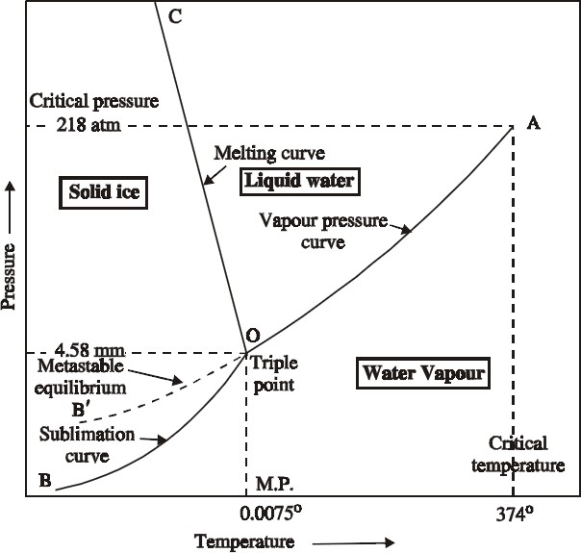

It helps in

1. Predicting whether an eutectic alloy (or) a solid solution is formedon cooling a homogeneous liquid containing mixture of two metals.
2. Understanding the properties of materials in the heterogeneous equilibrium system.
3. Studying of low melting eutectic alloys, used in soldering.

APPLICATIONS OF PHASE RULE**-** TO ONE COMPONENT SYSTEM

The Water System

Water exists in 3 possible phases, namely solid ice, liquid water and wate-rvapour. Hence, there can be three forms of equilibria, each involving two phases such as.

Solid Ice Liquid Water

Liquid Water Water **-** vapour Solid Ice Water **-** vapour

The phase diagram for the water system is as follows and it contains curves, areas, and triple point.

Curve OA

The curve OA is called vapourisationcurve, it represents the equilibrium between water and vapour.

At any point on the curve the followingequilibrium will exist.

Liquid Water Water **-** vapour

This equilibrium (i.e. line OA) will extend upto the critical temperature (374°C).

Beyond the critical temperature the equilibriumwill disappear and only watervapour will exist Curve OB

The curve OB is called sublimation curve of ice, it represents the equilibrium between solid ice and water-vapour.

At any point onthe curve the following equilibrium will exist.

Solid Ice Water **-** vapour

This equilibrium (i.e.line OB) will extend up to the absolute zero (−273°C)

Beyond absolute zero only solid ice will exist and no wate-rvapour. Curve OC

The curve OC is called melting point curve of ice, it represents the equilibrium between ice and water.

At any point on the curve the following equilibrium will exist.

Solid Ice Liquid Water

The curve OC is slightly incline d towards pressure axis. This shows that melting point of ice decreases with increase of pressure.

Curve OB (Metastable Equilibrium)

The curve OB is called vapour pressure curveof the super-cooled water (or) metastable equilibrium where the following equilibrium will exist.

Super **-** cooled water Water **-** vapour

Sometimes water can be cooled below it’s freezing point (0°C) without the formation of ice, this water is called super-cooled water.

Super cooled water is unstable and it can be converted into solid ice by “seeding” (or) by slight disturbance.

Along the curv es OA,OB,OC and OB

The no. of phases(P) is 2 ,component(C) is 1 and the degree of freedom of the system is one i.e., univariant. This is predicted by the phase rule:

F = C − P + 2; F = 1 − 2 + 2; F = 1

Therefore, either temperature (or) pressrue must be fixed to define the system. Point ‘O’ (Triple point)

The three curves OA, OB and OC meet at a point ‘O’, where three phases namely solid ice, liquid water and water-vapour are simultaneously at equilibrium.

This point is called triple point, at this point the following equilibrium will exist Ice(s) Water(l) Vapour(g)

At this point the no. of phases(P) is 3, component(C) is 1 and the degree of freedom of the system is zero

i.e., nonvariant. This is predicted by the phase rule: F = C − P + 2; F = 1 − 3 + 2; F = 0

This takes place only at a constanttemperature (0.0075°C) and pressure (4.58 mm of Hg).

Areas

Areas AOC, BOC, AOB represents liquid water, solid ice and water-vapour respectively where the no. of phases(P) and component(C) are one. Hence the degree of freedom of the system is two i.eb.i,variant. This is predicted by the phase rule:

F = C − P + 2; F = 1 − 1 + 2; F = 2

Therefore, both temperature and pressure must be fixetdo define the system at any point in the areas. TWO COMPONENT ALLOY SYSTEM (or) MULTI COMPONENT EQUILIBRIA

Reduced Phase Rule (or) Condensed System

The maximum number of degrees of freedom for a tow component system will be three, when the system exists as a single phase.

F = C − P + 2; F = 2 − 1 + 2; F = 3

In order to represent the conditions of equilibrium graphically, it requires three-coordinates, namely

P, T and C. This requires three dimensional graph, which cannot be conveniently represented on paper. Therefore, any two of the three variables must be chosen for graphical representation.

A solid-liquid equilibrium of an alloy has practically no gaseous phase and the effect of pressure is negligible. Therefore, experiments are conducted under atmospheric pressure.

Thus, the system in which only the solid and liquid phases are considered and the gas phase is ignored is called acondensed system.

Since the pressure is kept constant, the phase rule becomes F = C − P + 1

This equation is called reduced phase rule(or) condensed phase rule.

Classification of Two Component System

Based on the solubility and reactive ability, the two component systems are classified into three

types.

(ii) Simple eutectic formatoi n.

1. (a) Formation of compound with congruent melting point.

(b) Formation of compound with incongruent melting point.

1. Formation of solid solution. (i) Simple Eutectic Formation

A binary system having two substances, which arecompletely miscible in the liquid state, but completely immiscible in the solid state, is known aseutectic (easy melt) system. They do not react chemically. Of the different mixtures of two substances, a mixture having the lowest melting point is known as theeutectic mixture.

(ii) (a) Formation of compound with congruent melting point

The binary alloy system with two substances form one or more compounds with definite proportions.

Of the compounds, a compound is said to have congruent meltingoipnt, if it melts exactly at a constant temperature into liquid, having the same composition as that of the solid.

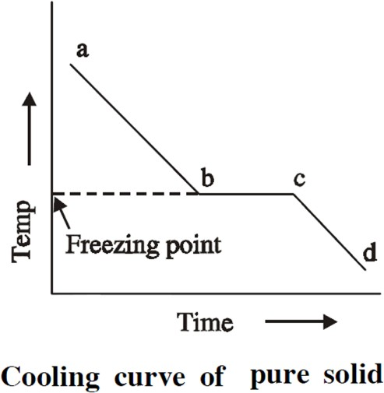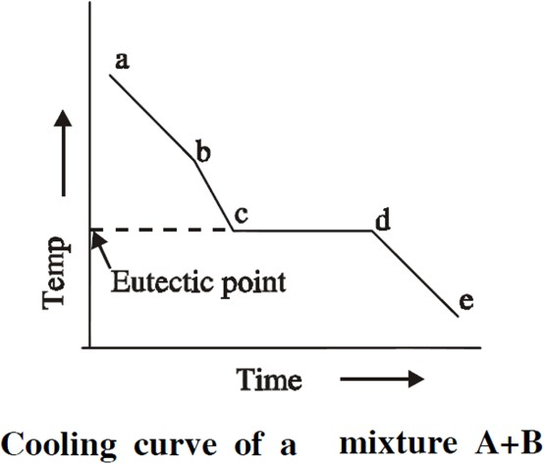

1. (b) Formation of compound with incongruent melting point

Of the above compounds, a compound is saidto have incongruentmelting point,

if it decomposes completely at a temperature below its melting point forming a new solid phase with a different composition from that of the original.

1. Formation of solid solution

A binary system in which two substances, eps ecially metals, are completely miscible in both solid and liquid states form solid solutions and their mixing takes place in the atomic levels. This happens only when the atomic radius of the two metals

not differ by more than 15%.

EXPERIMENTAL METHOD OF CONSTRUCTION OF A SIMPLE EUTECTIC PHASE DIAGRAM

Thermal Analysis (or) Cooling Curves

Thermal analysis is a method of studying the cooling curves of various compositions of a system during solidification. The shapes of the freezing point cruves for any system (involving metals) can be determined by thermal analysis. The form of cooling curves indicates the composition of the solid.

# Example 1:

A pure solid substance in the fused state is allowed to cool slowly and the temperature is notetd a different time intervals. Then a graph is plotted between temperature and time and it is cthoeoling curve for the pure solid substance.

Initially the rate of cooling of liquid melt is continuous from a‘ ’ till the point ‘ b’, where solid begins

to appear. Then the temperature remains constant until the liquid melt is completely solidified and solidification completes at the pointc‘’.

The horizontal line ‘bc’ represents the equilibrium between the solid and liquid melt. After the point ‘ c’, along the curve ‘cd’ cooling of solid mass begins and the temperature begins to decrease.

# Example 2:

If a mixture of two substances (say A and B) in the fused state are allowed to cool slowly, the cooling curve is obtained as above:

Initially the rate of cooling of liquid melt is continuous from‘a’ till the point‘b’ . When it reaches the point ‘b’ one substance (either A or B) begins to solidify out of the melt. This is indicated by a break where the rate of cooling is different. On further cooling at the breapkoint ‘c’ the second substance also begins to solidify. Now the temperature remains constant until the liquid melt is completely solidified, which forms the eutectic mixture along the line‘cd’ . After the break point ‘d’ cooling of solid mass begins. The temperature of horizontal linec‘d’ gives the eutectic temperature.

The experiment are repeated for different compositions of A and B and the various cooling curves are recorded.

From the cooling curves of various compositions, the main phase diagram cabne drawn by taking composition in X-axis and the temperature in Y-axis.

Uses of Cooling Curves:

1. Melting point and eutectic temperature can be noted.
2. Percentage purity of the compounds can be noted.
3. The behavior of the compounds can belcearly understood.
4. The composition corresponding to its freezing point yields the composition otfhe alloy.
5. The phase diagram for any two component system can be obtained.

BINARY ALLOY SYSTEM (OR) THE SIMPLE EUTECTIC SYSTEM

The Lead **-**Silver System

The Lead-Silver system is studied at constant pressure and the vapour phase is ignored. Hence the condensed phase rule is used:

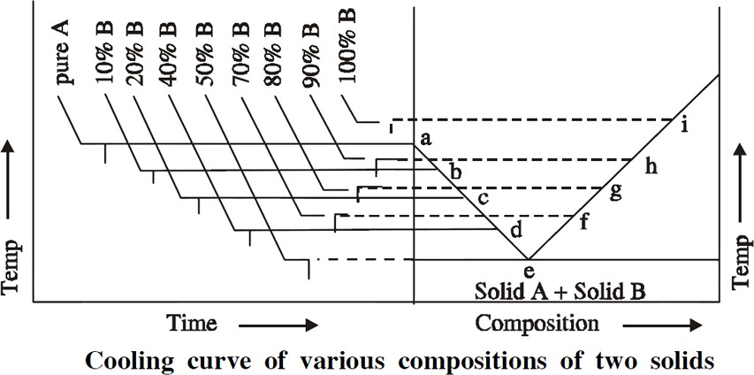

point.

F = C − P + 1

The phase diagram of lead-silver system is shown as follows. It contains curves, areas and eutectic

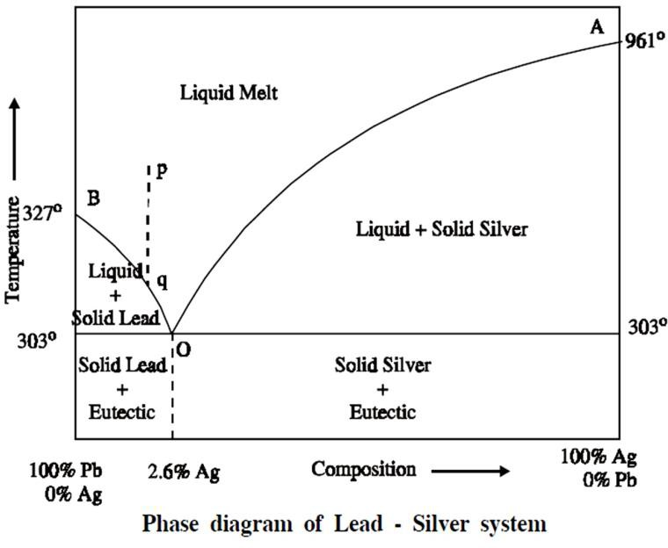

1. Curve AO

The curve AO is known as freezing point curve of silver. Point A is the melting point of pure Ag (961°C). The curve AO shows the melting point depression of Ag by the successive addition of Pb. Along this curve AO, solid Ag and the melt are in equilibrium.

# Solid Ag Liquid Melt

F = C − P + 1; F = 2 − 2 + 1; F = 1

1. Curve BO

The curve BO is known as freezing point curve of lead. Point B is the melting point of pure lead (327°C). The curve BO shows the melting point depression of Pb by the successive addition of Ag. Along this curve BO, solid Pb and the melt are in equilibrium.

# Solid Pb Liquid Melt

F = C − P + 1; F = 2 − 2 + 1; F = 1

Along the curves AO and BO

The system is univariant which means either temperature (or) compotisoi n must be fixed to define the system.

1. Point ‘O’ (Eutectic point)

The curves AO and BO meet at point ‘O’ at a temperature of303°C, where three phases (solid Ag, solid Pb and their liquid melt) are in equilibrium.

# Solid Ag + Solid Pb Liquid Melt

According to reduced phase rule equation.

F = C − P + 1; F = 2 − 3 + 1; F = 0

The system is non-variant.

The point ‘O’ is called eutectic point or eutectic temperature and its corresponding composition, 97.4%Pb + 2.6%Ag, is called eutectic composition.

Below this point the eutectic compoundand the metal solidify. (iv) Area

The area above the line AOB has a single phase (molten Pb+Ag) or liquid melt.

According to reduced phase rule the degree of freedom.

F = C − P + 1; F = 2 − 1 + 1; F = 2

The system is bivariant which means both the temperature and composition have to be fixed to define the system completely.

The area below the line AO (solid Ag + liquid melt), below the line BO (solid Pb + liquid melt) and below the point ‘O’ (Eutectic compound + solid Ag or solidPb) have two phases and hence the system is univariant

F = C − P + 1; F = 2 − 2 + 1; F = 1 .

Application of Pattinson’s process for the desilverisation of Argentiferous lead

The argentiferous lead, having a very small amount of silver (say 0.1%), is heated to a temperature above its melting point, so thathe system has only the liquid phase represented by the poinpt’ i‘n the phase diagram.

It is then allowed to cool where the temperature decreases along the linpeq‘’. As soon as the point ‘ q’ is reached, Pb is crystallised out and the solution will contain relatively increasing amounts of ‘Ag’. On

further cooling, more and more of ‘Pb’ is separated along the line ‘BO’. The melt continues to be richer and richer in Ag until the point ‘O’ is reached, where the percentage oAf g rises to 2.6%.

Thus, the process of raising the relative proportions of Ag in the alloy is known asPattinson’s process.

Uses of Eutectic system

1. Suitable alloy composition can be predicted.
2. Making solders, used for joining two metal pieces together.

# Differences between Melting point, Eutectic point and Triple point

1. **Melting Point:** It is the temperature at which the solid and liquid phases, having the same composition, are in equilibrium.

# Solid A Liquid A

1. **Eutectic Point:** It is the temperature at which two solids and a liquid phase are in equilibrium

# Solid A + Solid B Liquid

1. **Triple Point**

It is the temperature at which three phases are in equilibrium.

# Solid Liquid Vapour

All the eutectic points are melting points

All the melting points need not be eutectic points.

Similarly all the eutectic points are triple points, but all the triple points need not be eutectic points.